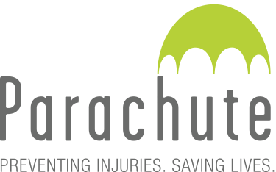
Cycling
Canadian Legislation Chart
Province/Territory | Bike Helmet Legislation¹ | Required Use of Lights/Reflectors at Night | Required Use of Bells/Horns² | “Dooring” Legislation³ | Minimum Passing Distance⁴
British Columbia  Motor Vehicle Act | Applies to all ages | Yes | No | Yes | No
Alberta  Traffic Safety Act — Vehicle Equipment Regulation (AR 122/2009), Use of Highway and Rules of the Road (AR 304/2002) | Applies to those under  18 years | Yes | No | Yes | 1m
Saskatchewan | No provincial law  Applies to only those under 16 years of age in Moose Jaw and Estevan. Applies to all ages in North Battleford and Yorkton. | No | No | No | No
Manitoba  Highway Traffic Act | Applies to those under  18 years | Yes | No | Yes | No
Ontario  Highway Traffic Act | Applies to those under  18 years | Yes | Yes | Yes | 1m
Quebec  Highway Safety Code | No provincial law  Applies to only those under 18 years in Sherbrooke. Applies to all ages in Cote Saint-Luc and Westmount. | Yes | No | Yes | 1.5m*  *On roads >50km/h (1m on roads 50 km/h or less)
New Brunswick  Motor Vehicle Act | Applies to all ages | Yes | Yes | Yes | 1m
Nova Scotia  Motor Vehicle Act  New Traffic Safety Act in 2019, not yet in effect | Applies to all ages | Yes | Yes | No  *Changes proposed in new Traffic Safety Act | 1m
Prince Edward Island  Highway Traffic Act | Applies to all ages | Yes | Yes | Yes | 1m
Newfoundland and Labrador  Highway Traffic Act | Applies to all ages | Yes | No | Yes | 1.5m*  *On roads >60km/h (1m on roads 60 km/h or less)
Yukon  Motor Vehicle Act | No provincial law  Applies to all ages in Whitehorse | Yes | No | Yes | No
Northwest Territories  Motor Vehicles Act | No provincial law  Applies to only those under 18 years of age in Yellowknife. Applies to all ages in Fort Smith and Inuvik. | No | No | Yes | No
Nunavut  Motor Vehicles Act | No provincial law | No | No | Yes | No

1 For information purposes only. Please consult local authorities for further interpretation and current status.
2 Varies by municipality.
3 “Dooring” legislation refers to legislation prohibiting unsafe practices respecting opening the door of a motor vehicle.
4 Some municipalities have passed minimum passing distance bylaws.

